**SQL Query Code (Lab Excercise)**

**Introduction to SQL**

**Lab 1: Create a new database named school_db and a table called students with the following columns: student_id, student_name, age, class, and address.**

**CODE:**

**CREATE DATABASE school_db;**

**USE school_db;**

**CREATE TABLE students ( student_id INT PRIMARY KEY, student_name VARCHAR(100),age INT,class VARCHAR(20),address VARCHAR(255));**

**SCREENSHOT:**

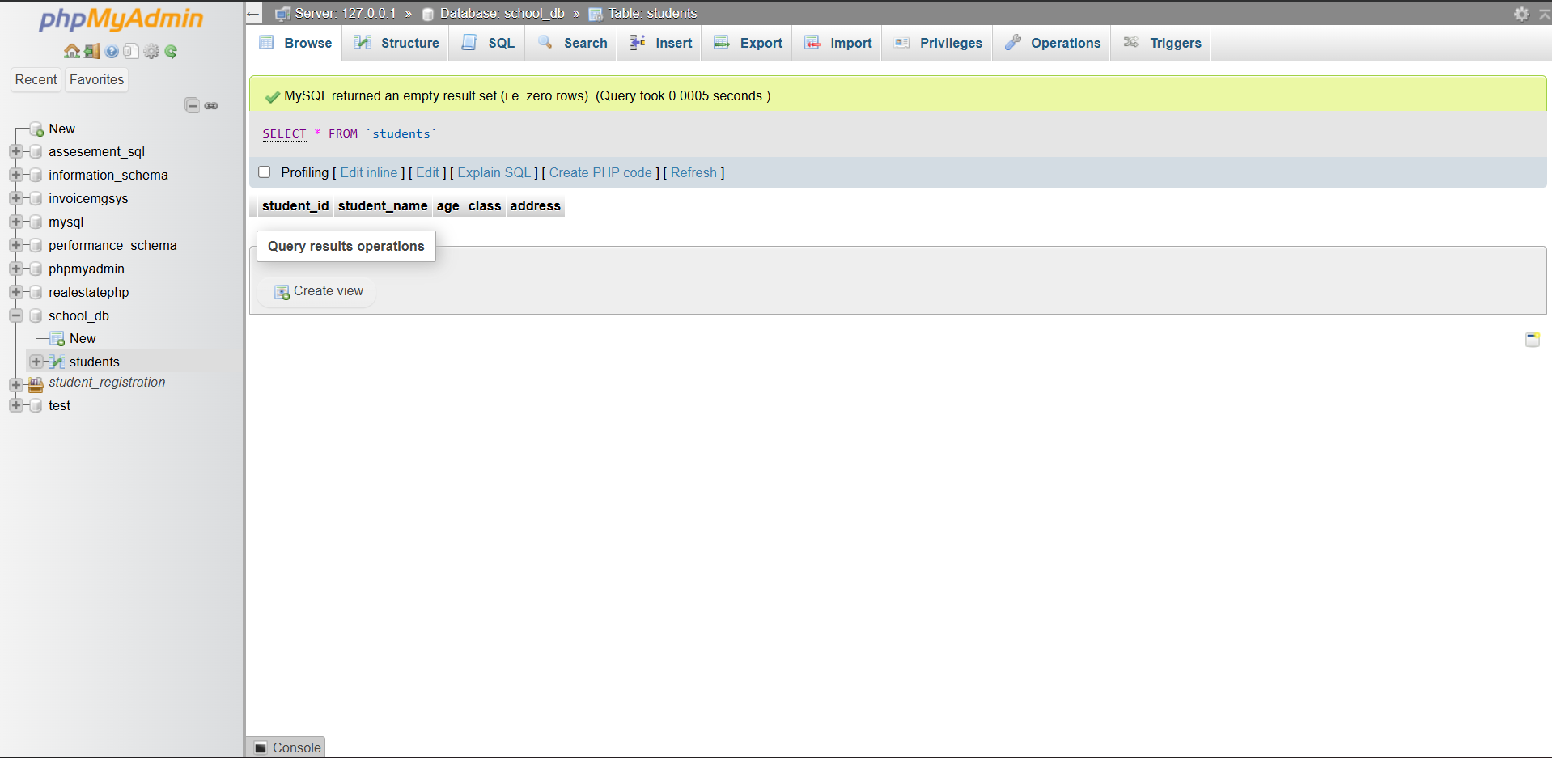

**Lab 2: Insert five records into the students table and retrieve all records using the SELECT statement.**

**CODE:**

**INSERT INTO students (student_id, student_name, age, class, address) VALUES**

**(1, 'Rohan Patel', 15, '10A', 'Rajkot'),**

**(2, 'Meera Shah', 14, '9B', 'Ahmedabad'),**

**(3, 'Kunal Mehta', 16, '11C', 'Surat'),**

**(4, 'Priya Desai', 15, '10B', 'Vadodara'),**

**(5, 'Aarav Joshi', 13, '8A', 'Jamnagar');**

**SELECT * FROM students;**

**SCREENSHOT:**

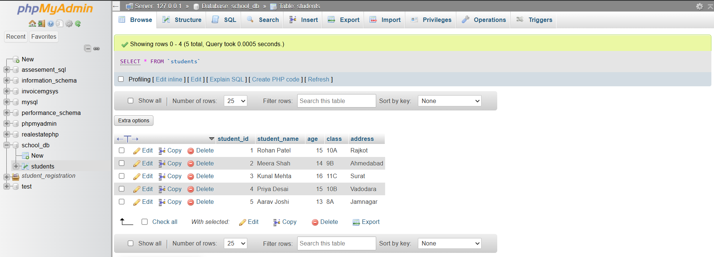

**SQL Syntax**

**Lab 1: Write SQL queries to retrieve specific columns (student_name and age) from the students table.**

**Code:**

**SELECT student_name, age FROM students;**

**SCREENSHOT:**

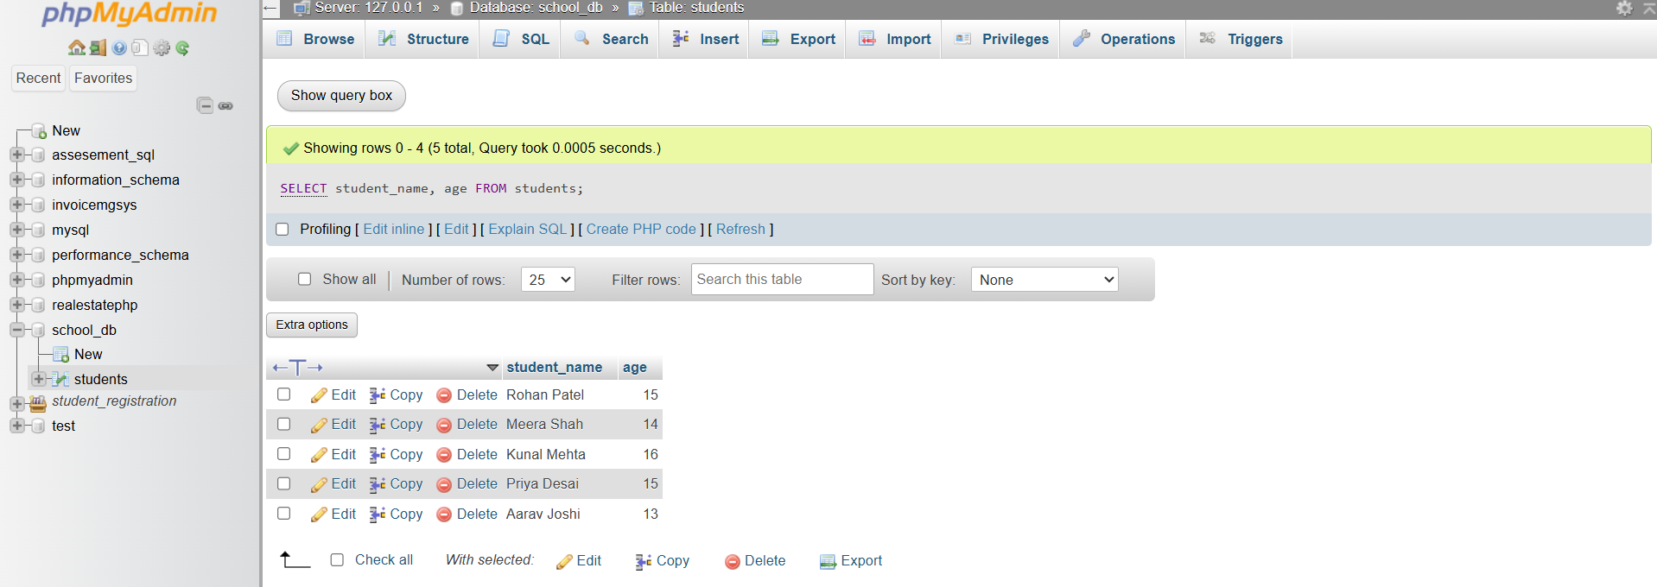

**Lab 2: Write SQL queries to retrieve all students whose age is greater than 10.**

**CODE:**

**SELECT * FROM students**

**WHERE age > 10;**

**SCREENSHOT:**

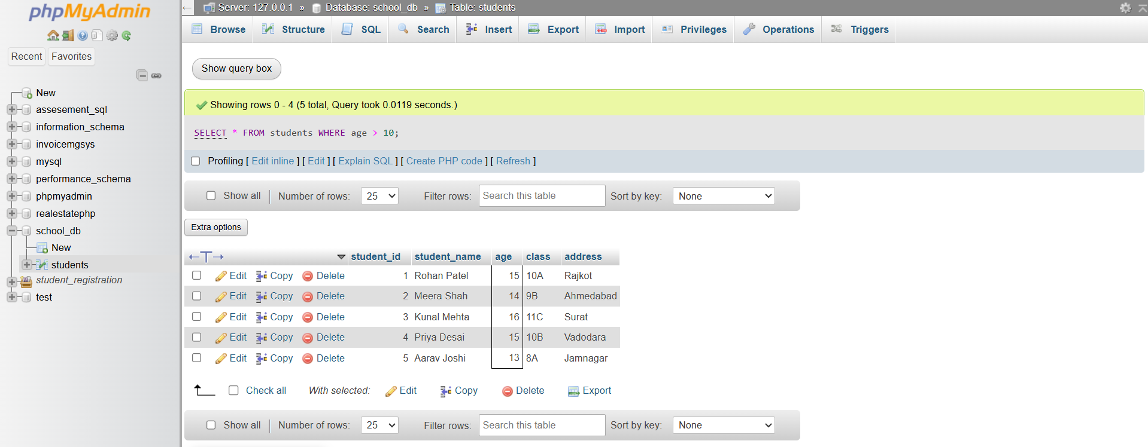

**SQL Constraints**

**Lab 1: Create a table teachers with the following columns: teacher_id (Primary Key), teacher_name (NOT NULL), subject (NOT NULL), and email (UNIQUE).**

**CODE:**

**CREATE TABLE teachers (**

**teacher_id INT PRIMARY KEY,**

**teacher_name VARCHAR(100) NOT NULL,**

**subject VARCHAR(100) NOT NULL,**

**email VARCHAR(150) UNIQUE**

**);**

**SCREENSHOT:**

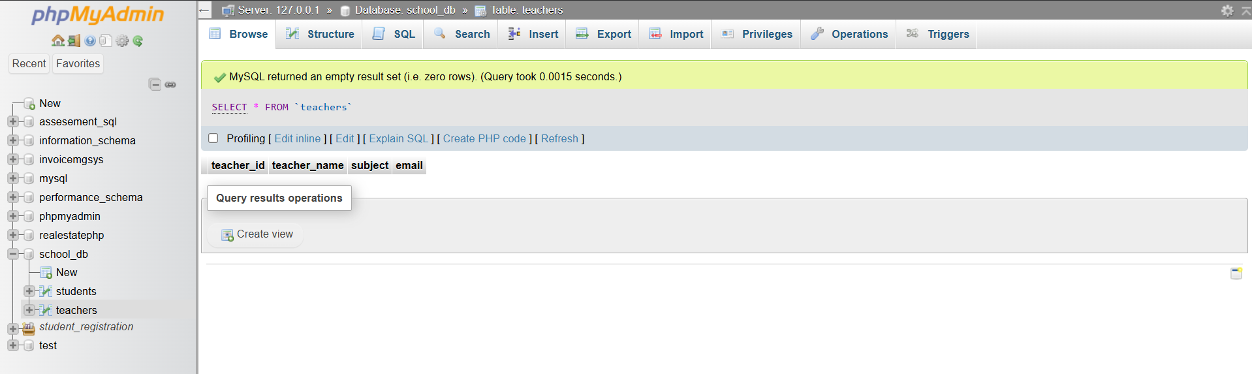

**Lab 2: Implement a FOREIGN KEY constraint to relate the teacher_id from the teachers table with the students table.**

**CODE:**

**ALTER TABLE students**

**ADD teacher_id INT;**

**ALTER TABLE students**

**ADD CONSTRAINT fk_teacher**

**FOREIGN KEY (teacher_id)**

**REFERENCES teachers(teacher_id);**

**SCREENSHOT:**

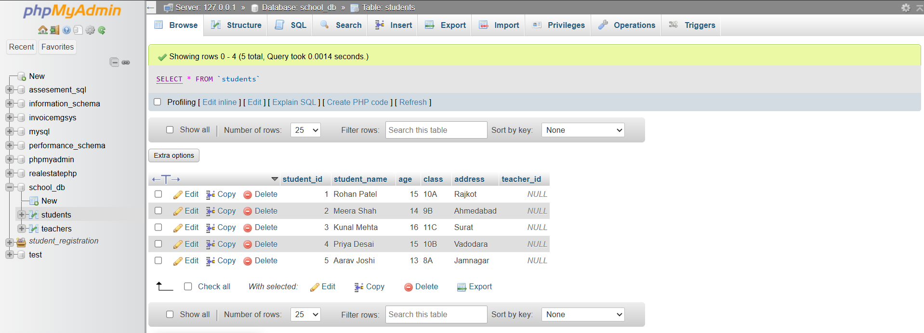

**Main SQL Commands and Sub-commands (DDL)**

**Lab 1: Create a table courses with columns: course_id, course_name, and course_credits. Set the course_id as the primary key.**

**CODE:**

**CREATE TABLE courses (**

**course_id INT PRIMARY KEY,**

**course_name VARCHAR(100),**

**course_credits INT**

**);**

**SCREENSHOT:**

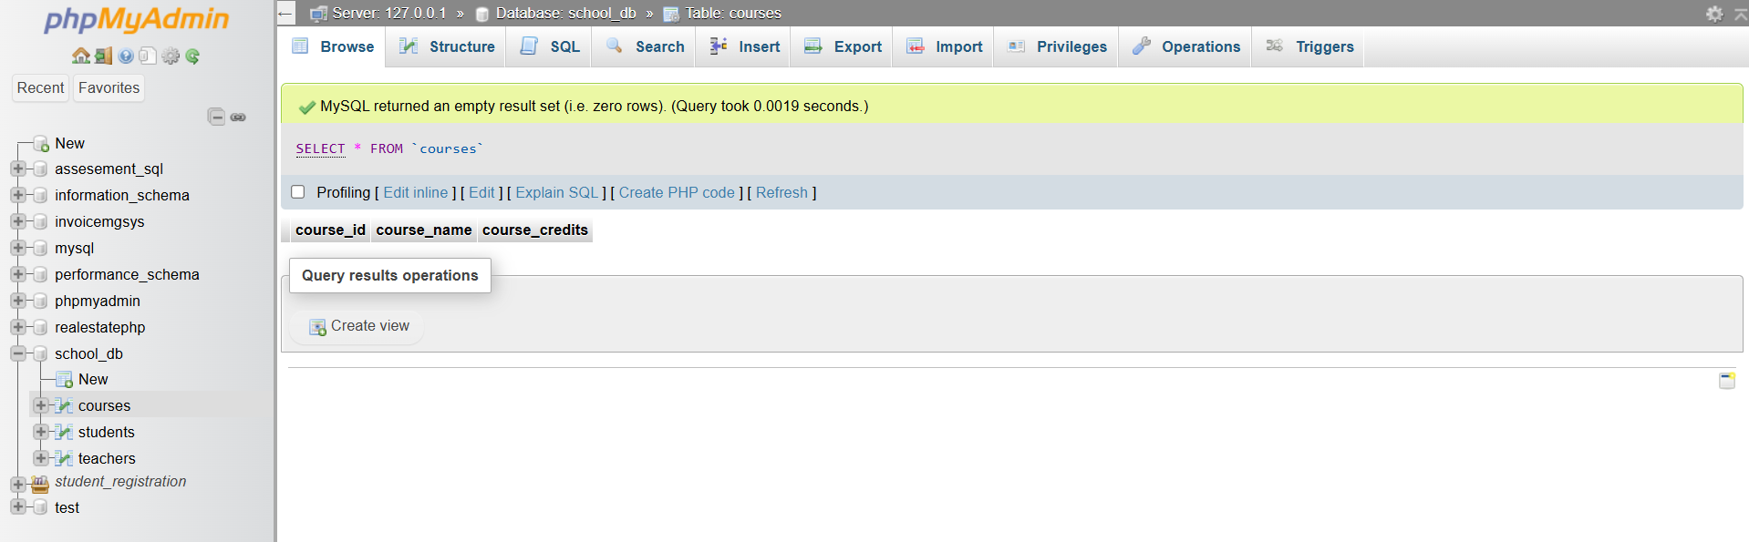

**Lab 2: Use the CREATE command to create a database university_db.**

**CODE:**

**CREATE DATABASE university_db;**

**SCREENSHOT:**

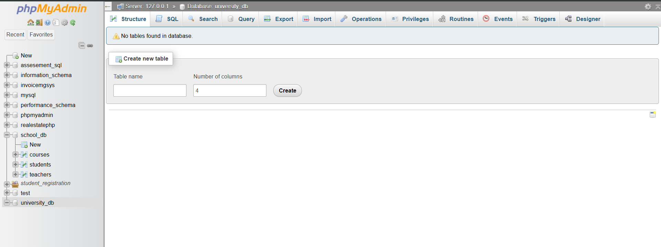

**ALTER Command**

**Lab 1: Modify the courses table by adding a column course_duration using the ALTER command.**

**CODE:**

**ALTER TABLE courses**

**ADD course_duration VARCHAR(50);**

**SCREENSHOT:**

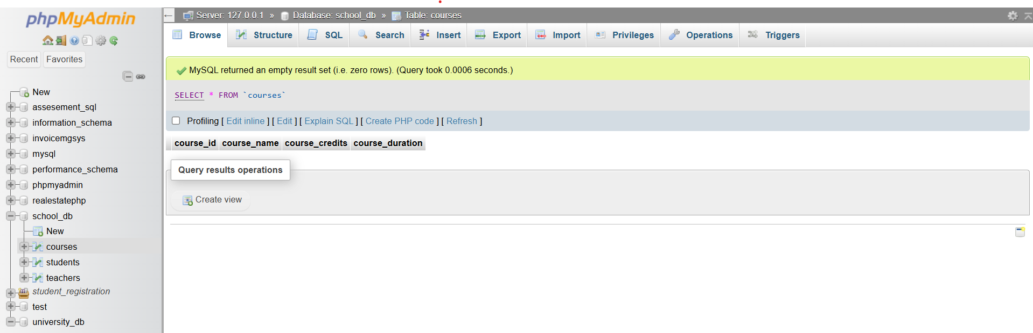

**Lab 2: Drop the course_credits column from the courses table.**

**CODE:**

**ALTER TABLE courses**

**DROP COLUMN course_credits;**

**SCREENSHOT:**

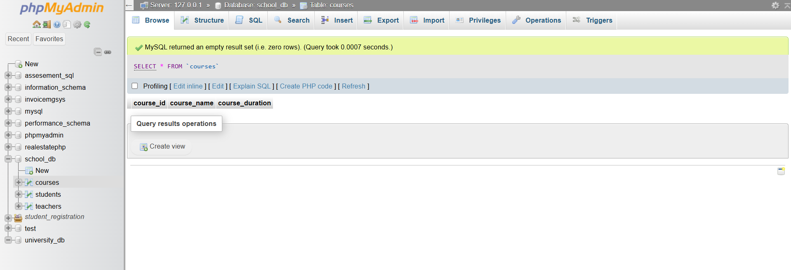

**DROP Command**

**Lab 1: Drop the teachers table from the school_db database.**

**CODE:**

**ALTER TABLE students**

**DROP FOREIGN KEY fk_teacher;**

**USE school_db;**

**DROP TABLE teachers**

**SCREENSHOT:**

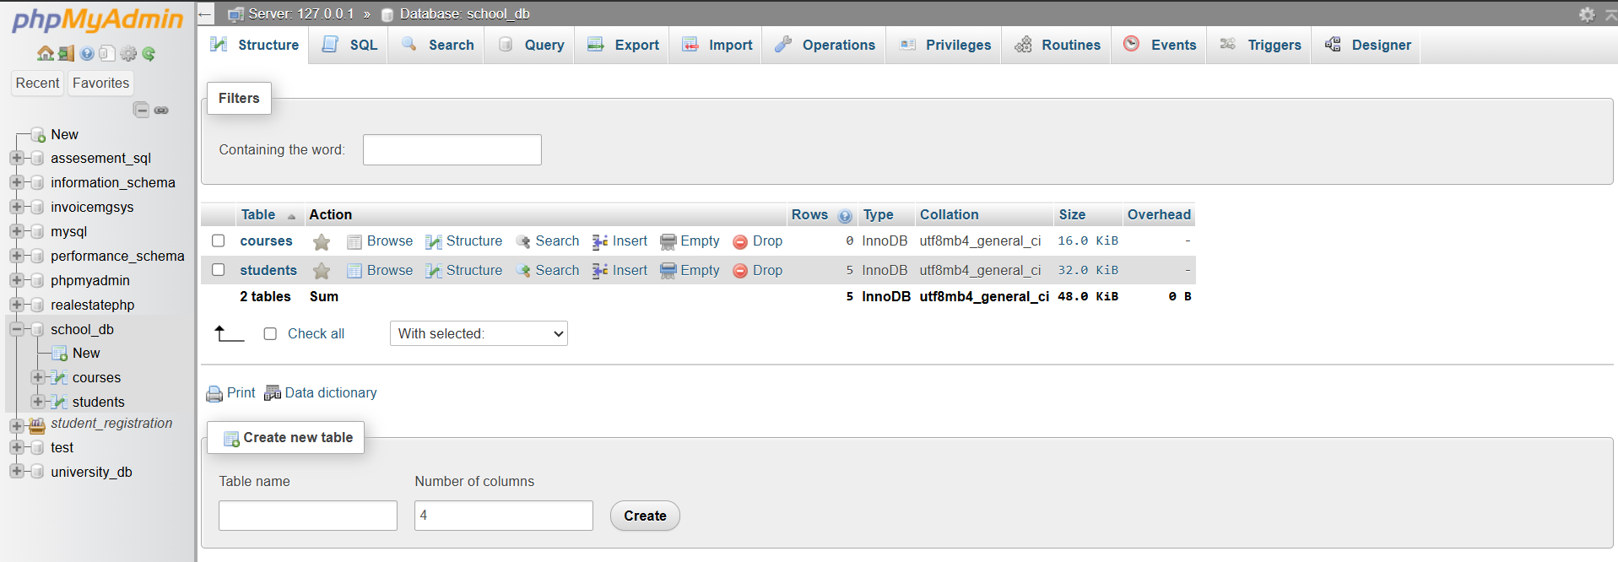

**Lab 2 : Drop the students table from the school_db database and verify that the table has been removed.**

**CODE:**

**DROP TABLE students;**

**SCREENSHOT:**

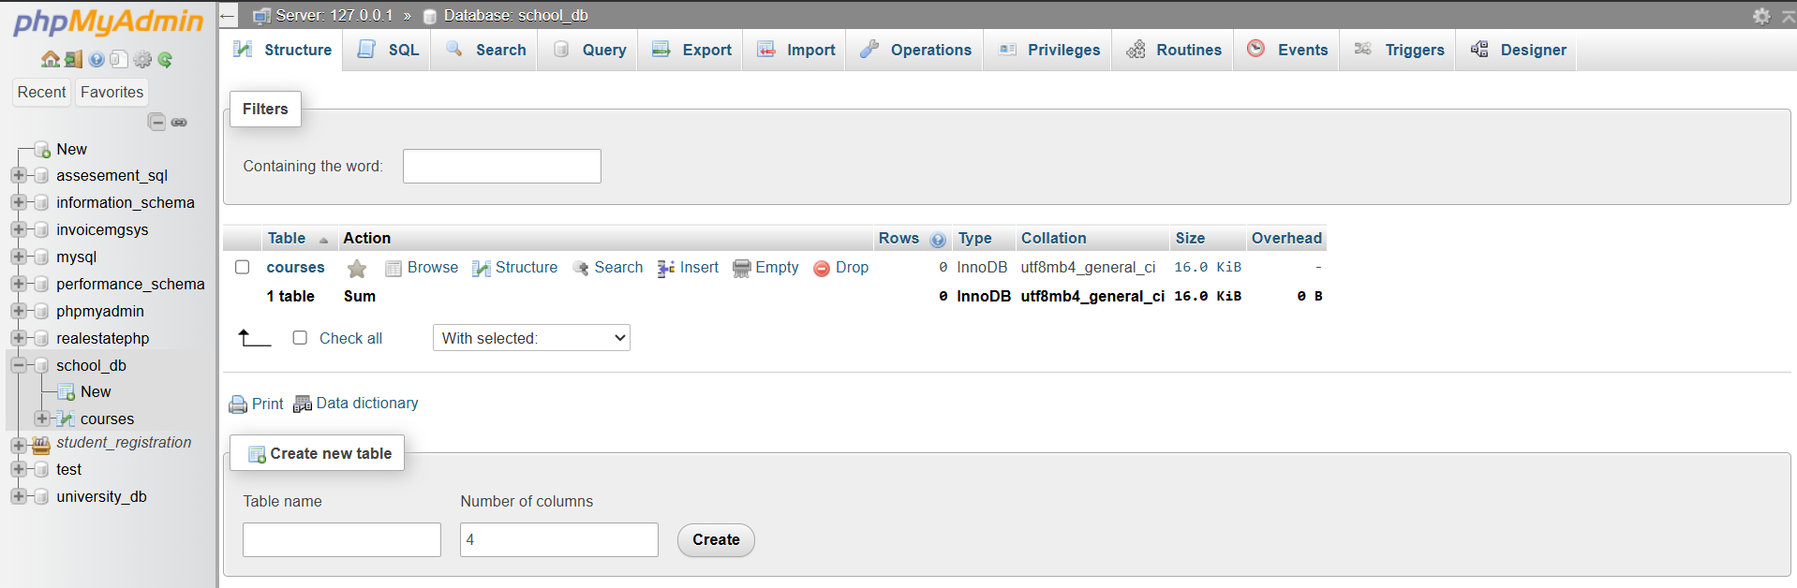

**Data Manipulation Language (DML)**

**Lab 1: Insert three records into the courses table using the INSERT command.**

**CODE:**

**INSERT INTO courses (course_id, course_name, course_duration)**

**VALUES (1, 'Mathematics', '6 months');**

**INSERT INTO courses (course_id, course_name, course_duration)**

**VALUES (2, 'Science', '6 months');**

**INSERT INTO courses (course_id, course_name, course_duration)**

**VALUES (3, 'English', '6 months');**

**SCREENSHOT:**

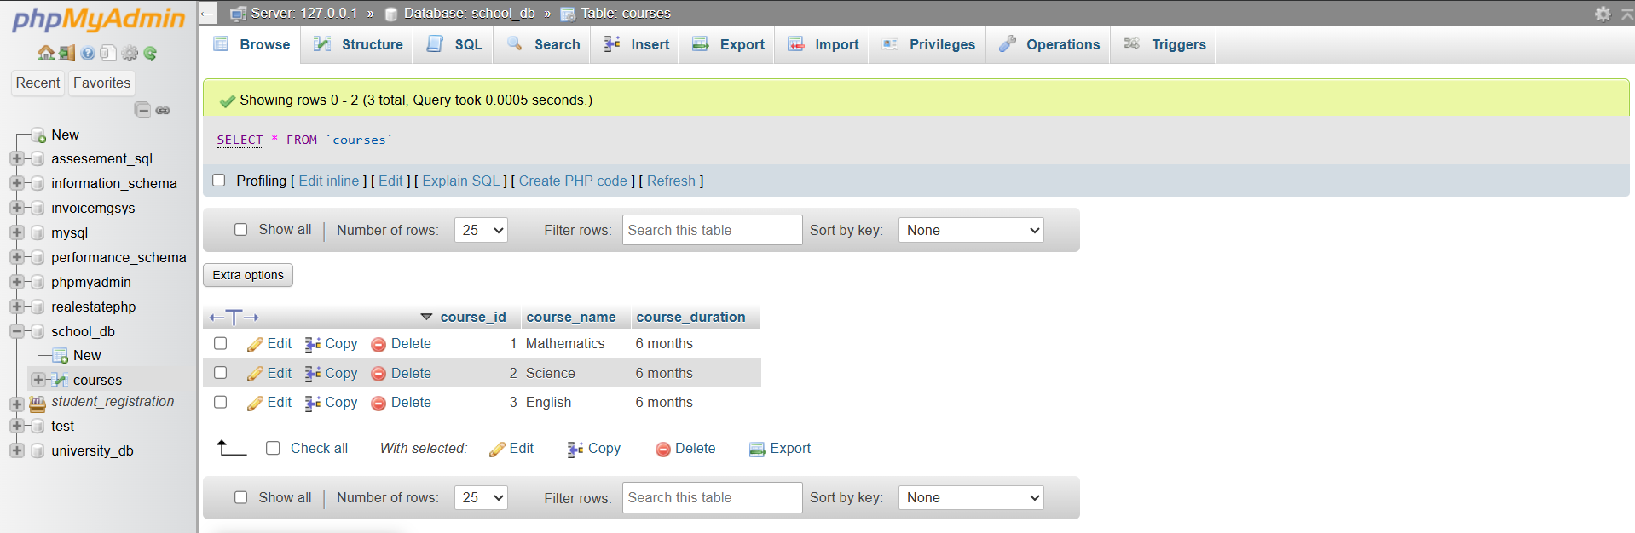

**Lab 2: Update the course duration of a specific course using the UPDATE command.**

**CODE:**

**UPDATE courses**

**SET course_duration = '12 months'**

**WHERE course_name = 'Mathematics';**

**SCREENSHOT:**

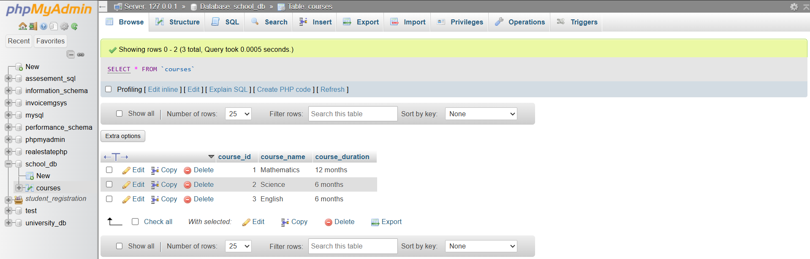

**Lab 3: Delete a course with a specific course_id from the courses table using the DELETE command.**

**CODE:**

**DELETE FROM courses**

**WHERE course_id = 2;**

**SCREENSHOT:**

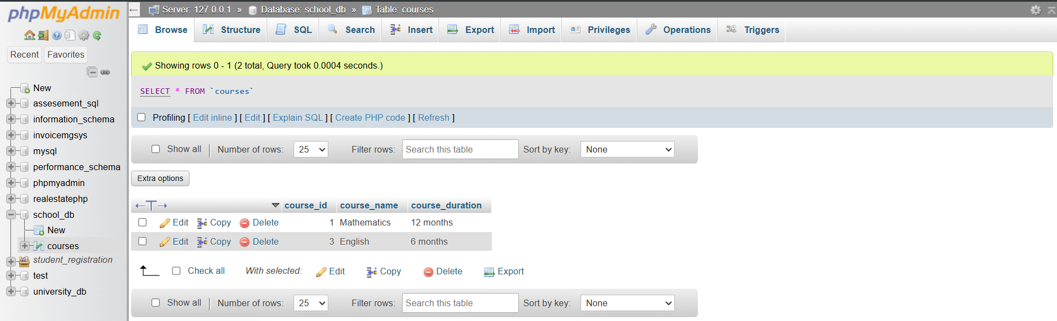

**Data Query Language (DQL)**

**Lab 1: Retrieve all courses from the courses table using the SELECT statement.**

**CODE:**

**SELECT * FROM courses;**

**SCREENSHOT:**

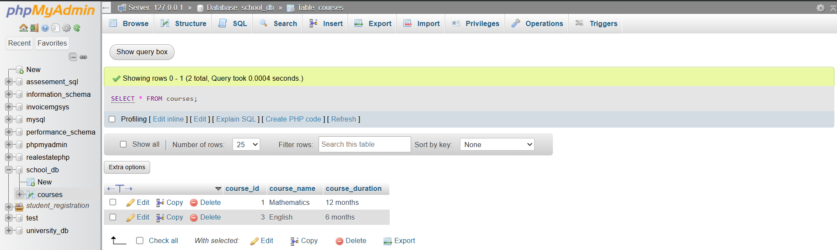

**Lab 2: Sort the courses based on course_duration in descending order using ORDER BY.**

**CODE:**

**SELECT \***

**FROM courses**

**ORDER BY course_duration DESC;**

**SCREENSHOT:**

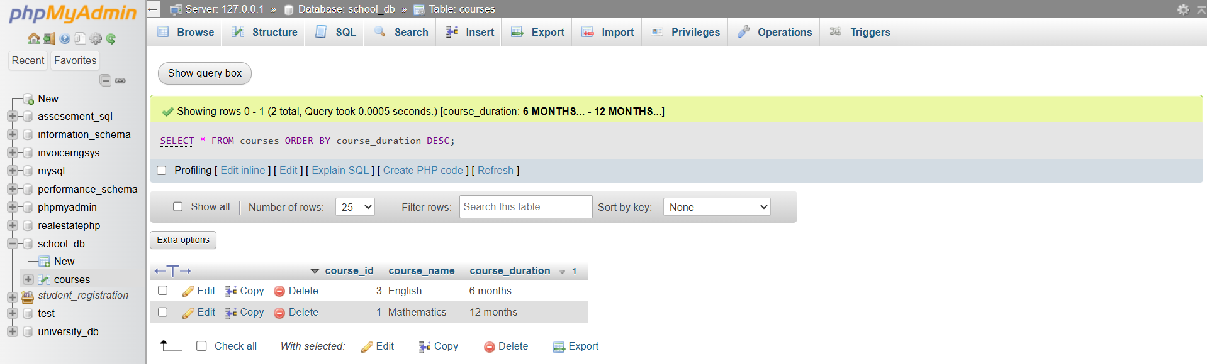

**Lab 3: Limit the results of the SELECT query to show only the top two courses using LIMIT.**

**CODE:**

**SELECT * FROM courses LIMIT 2;**

**SCREENSHOT:**

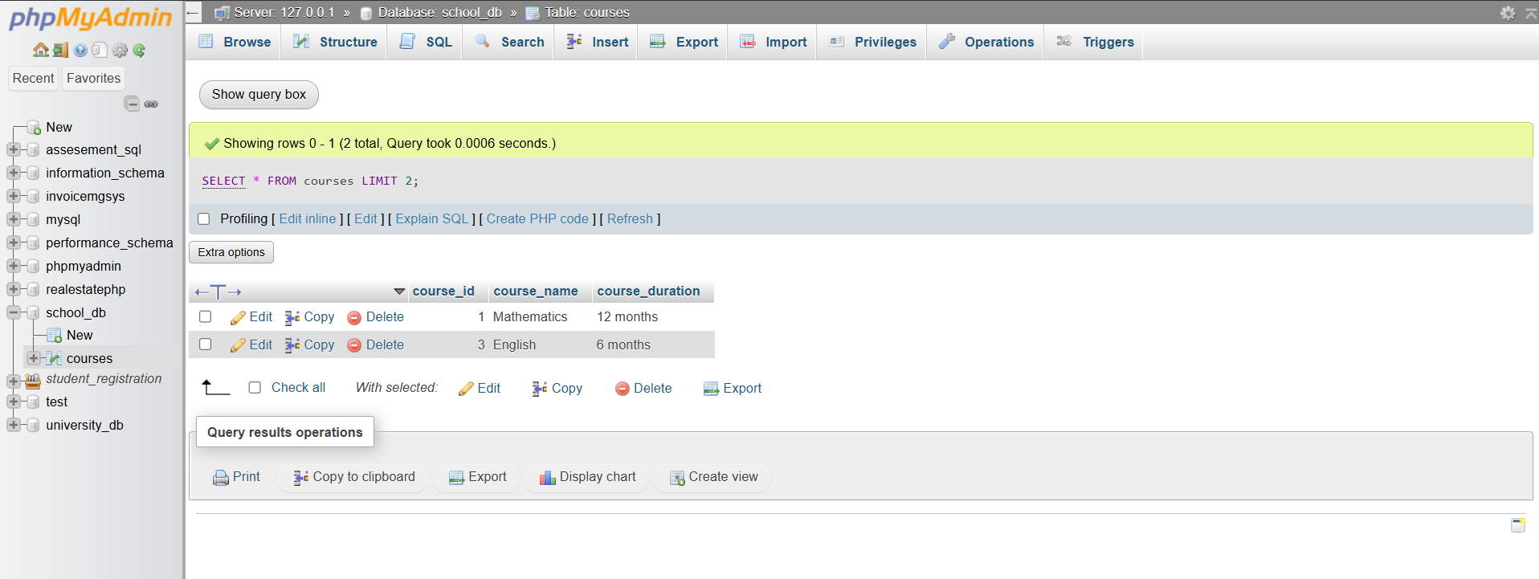

**Data Control Language (DCL)**

**Lab 1: Create two new users user1 and user2 and grant user1 permission to SELECT from the courses table.**

**CODE:**

**CREATE USER 'user1'@'localhost' IDENTIFIED BY 'pass1';**

**CREATE USER 'user2'@'localhost' IDENTIFIED BY 'pass2';**

**GRANT SELECT ON school_db.courses TO 'user1'@'localhost';**

**SCREENSHOT:**

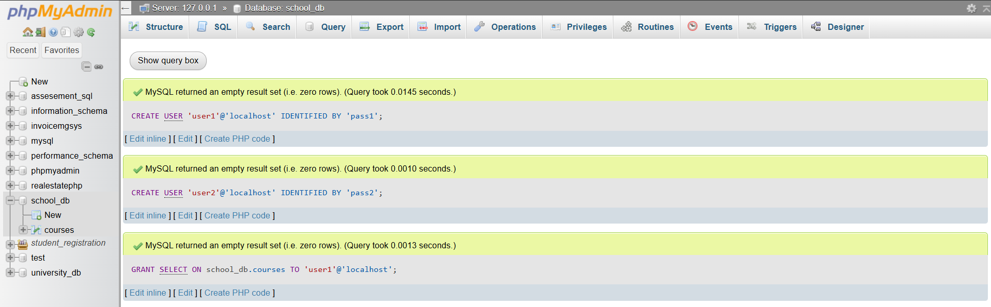

**Lab 2:Revoke the INSERT permission from user1 and give it to user2.**

**CODE:**

**REVOKE INSERT ON school_db.courses FROM 'user1'@'localhost';**

**GRANT INSERT ON school_db.courses TO 'user2'@'localhost';**

**SCREENSHOT:**

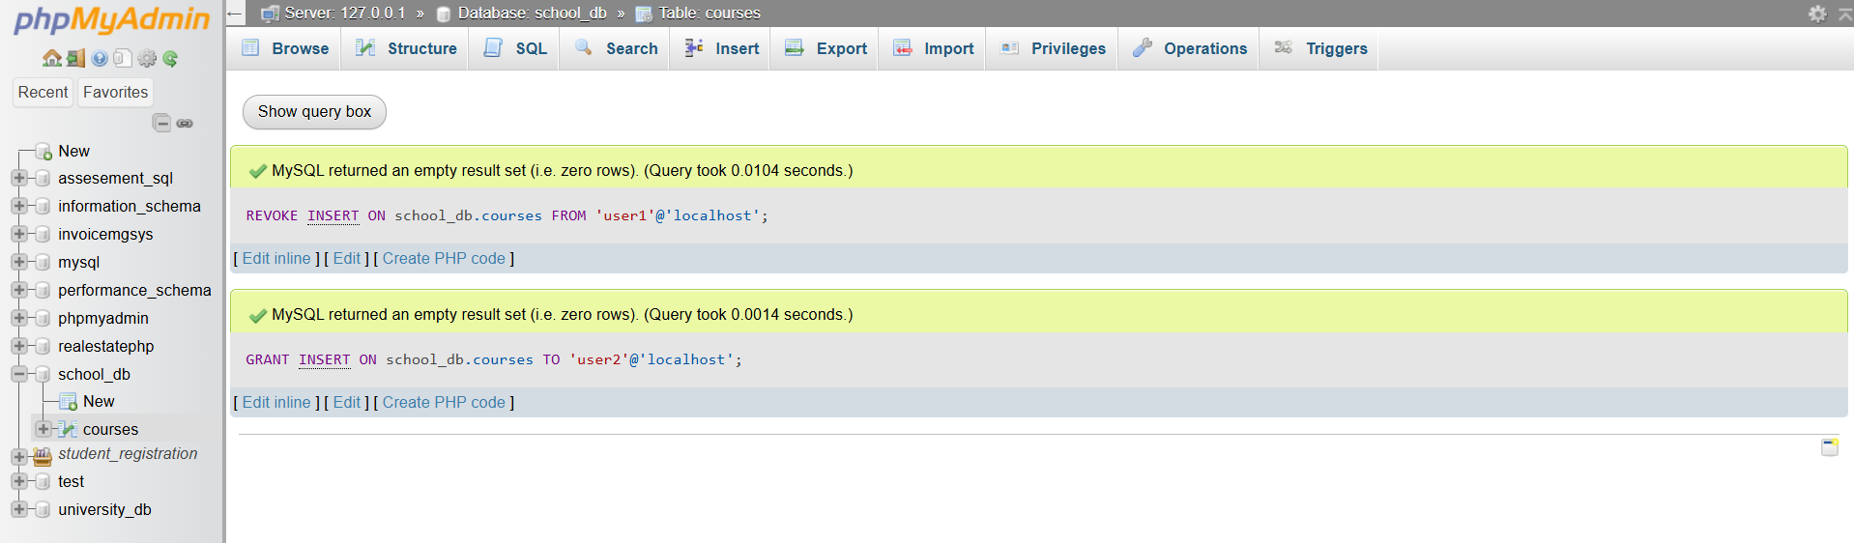

**Transaction Control Language (TCL)**

**Lab 1: Insert a few rows into the courses table and use COMMIT to save the changes.**

**CODE:**

**START TRANSACTION;**

**INSERT INTO courses (course_id, course_name, course_duration)**

**VALUES (4, 'History', '5 months');**

**INSERT INTO courses (course_id, course_name, course_duration)**

**VALUES (5, 'Geography', '4 months');**

**COMMIT;**

**SCREENSHOT:**

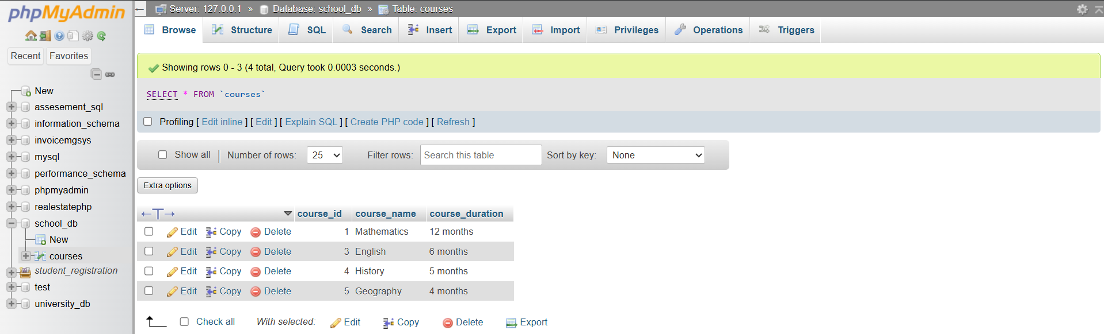

**Lab 2: Insert additional rows, then use ROLLBACK to undo the last insert operation.**

**CODE:**

**START TRANSACTION;**

**INSERT INTO courses (course_id, course_name, course_duration)**

**VALUES (6, 'Physics', '6 months');**

**INSERT INTO courses (course_id, course_name, course_duration)**

**VALUES (7, 'Chemistry', '6 months');**

**ROLLBACK;**

**SCREENSHOT:**

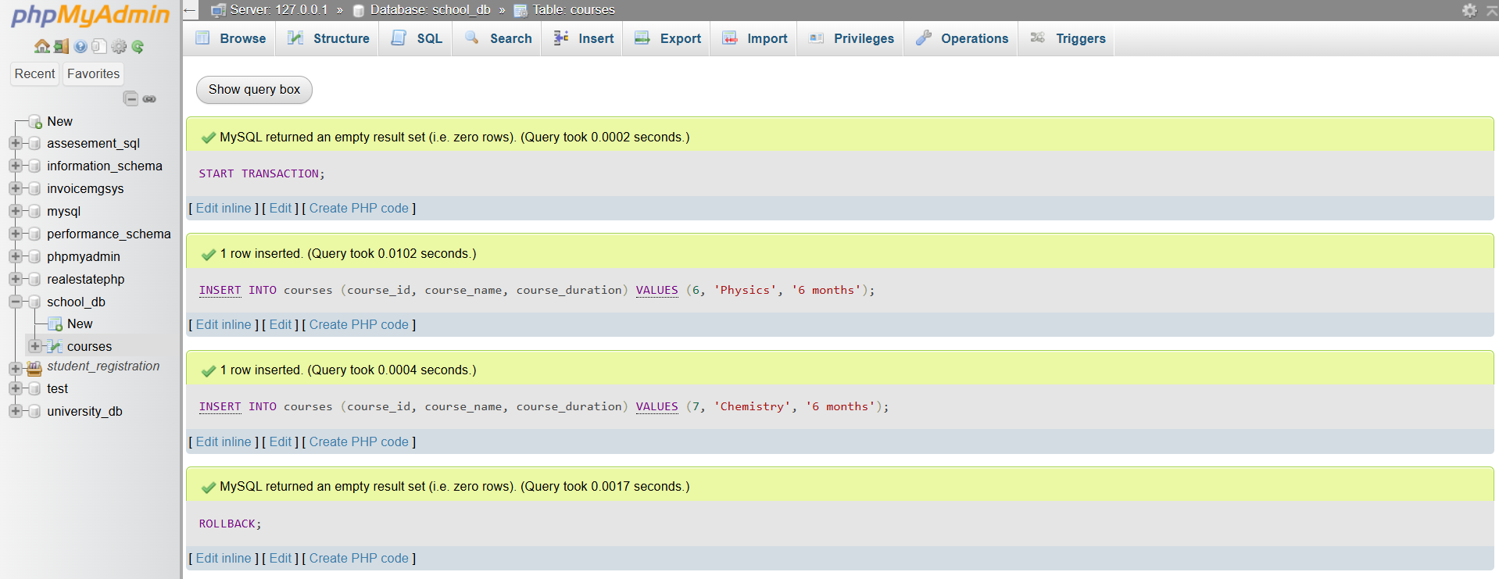

**Lab 3: Create a SAVEPOINT before updating the courses table, and use it to roll back specific changes.**

**CODE:**

**START TRANSACTION;**

**UPDATE courses**

**SET course_duration = '10 months'**

**WHERE course_name = 'Mathematics';**

**SAVEPOINT before_science_update;**

**UPDATE courses**

**SET course_duration = '8 months'**

**WHERE course_name = 'Science';**

**ROLLBACK TO SAVEPOINT before_science_update;**

**COMMIT;**

**SCREENSHOT:**

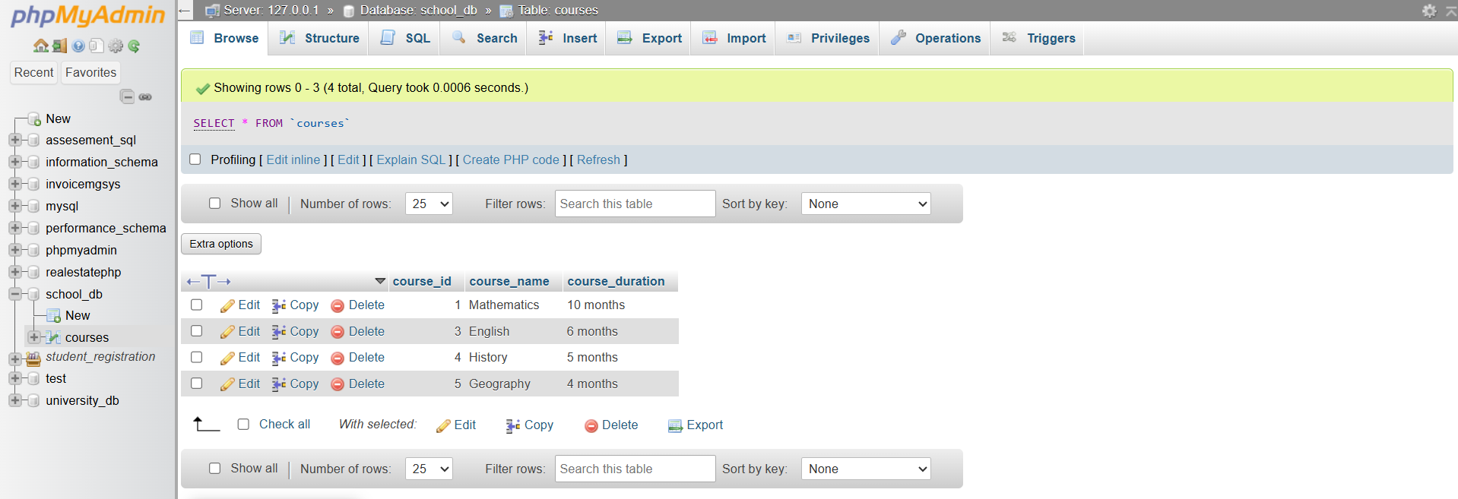

**SQL Joins**

**Lab 1: Create two tables: departments and employees. Perform an INNER JOIN to display employees along with their respective departments.**

**CODE:**

**Step 1 — Create the tables**

**CREATE TABLE departments (**

**department_id INT PRIMARY KEY,**

**department_name VARCHAR(100)**

**);**

**CREATE TABLE employees (**

**employee_id INT PRIMARY KEY,**

**employee_name VARCHAR(100),**

**department_id INT,**

**FOREIGN KEY (department_id) REFERENCES departments(department_id)**

**);**

**Step 2 — Insert sample data**

**INSERT INTO departments (department_id, department_name)**

**VALUES (1, 'HR'), (2, 'Finance'), (3, 'IT');**

**INSERT INTO employees (employee_id, employee_name, department_id)**

**VALUES (101, 'Alice', 1),**

**(102, 'Bob', 2),**

**(103, 'Charlie', 3),**

**(104, 'David', 2);**

**Step 3 — Perform INNER JOIN**

**SELECT employees.employee_name, departments.department_name**

**FROM employees**

**INNER JOIN departments**

**ON employees.department_id = departments.department_id;**

**SCREENSHOT:**

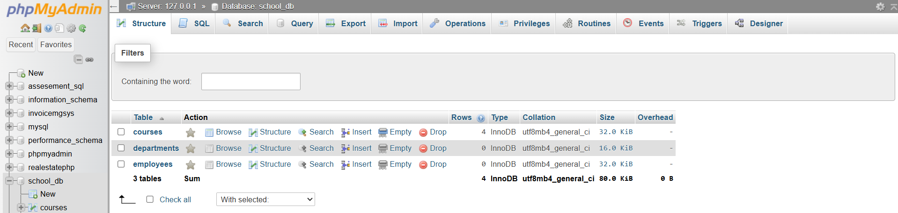

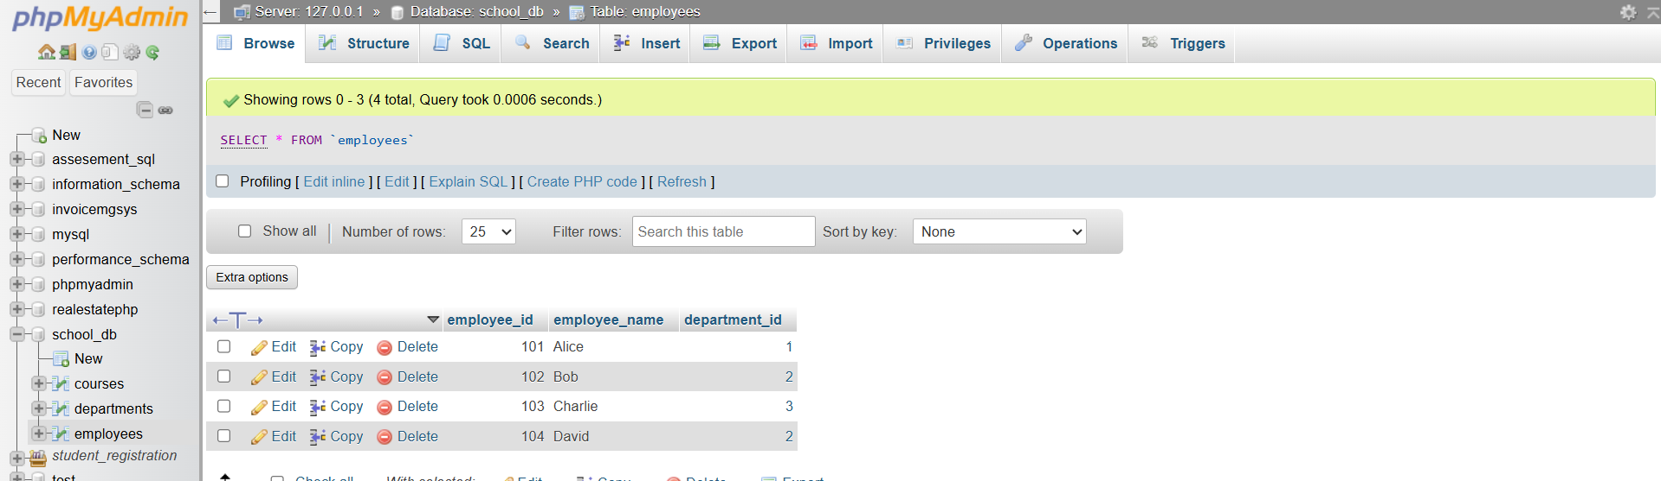

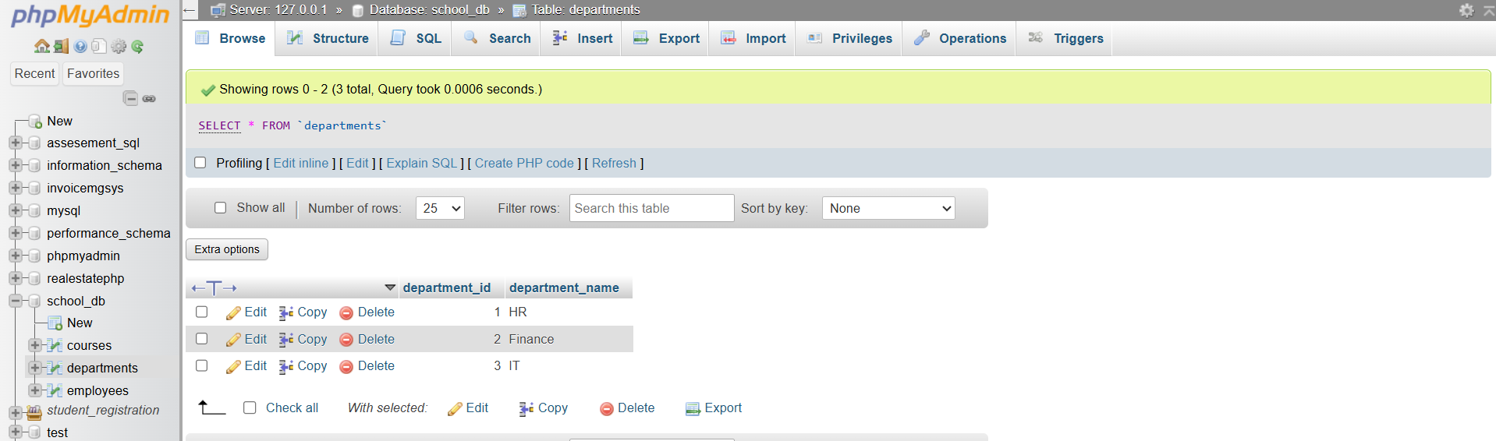

**Lab 2: Use a LEFT JOIN to show all departments, even those without employees.**

**CODE:**

**SELECT departments.department_name, employees.employee_name**

**FROM departments**

**LEFT JOIN employees**

**ON departments.department_id = employees.department_id;**

**SCREENSHOT:**

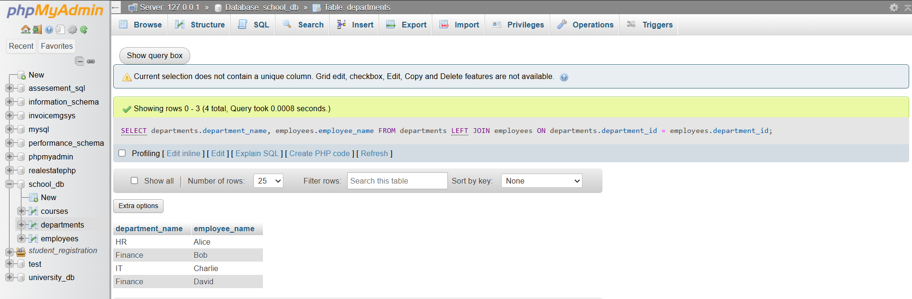

**SQL Group By**

**Lab 1: Group employees by department and count the number of employees in each department using GROUP BY.**

**CODE:**

**SELECT departments.department_name, COUNT(employees.employee_id) AS employee_count**

**FROM employees**

**INNER JOIN departments**

**ON employees.department_id = departments.department_id**

**GROUP BY departments.department_name;**

**SCREENSHOT:  
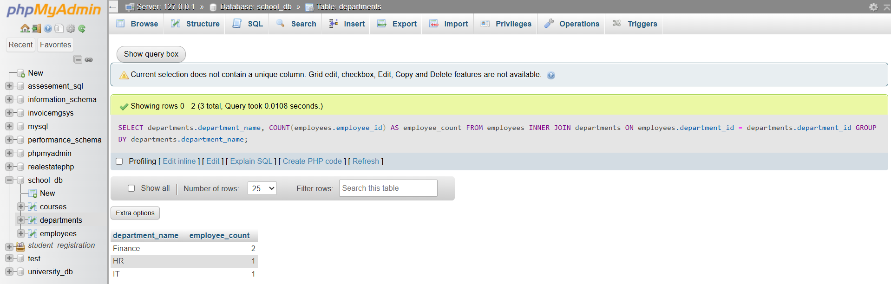**

**Lab 2: Use the AVG aggregate function to find the average salary of employees in each department.**

**CODE:**

**UPDATE employees**

**SET salary = 50000 WHERE employee_id = 101;**

**UPDATE employees**

**SET salary = 60000 WHERE employee_id = 102;**

**UPDATE employees**

**SET salary = 55000 WHERE employee_id = 103;**

**UPDATE employees**

**SET salary = 62000 WHERE employee_id = 104;**

**SELECT departments.department_name, AVG(employees.salary) AS average_salary**

**FROM employees**

**INNER JOIN departments**

**ON employees.department_id = departments.department_id**

**GROUP BY departments.department_name;**

**SCREENSHOT:**

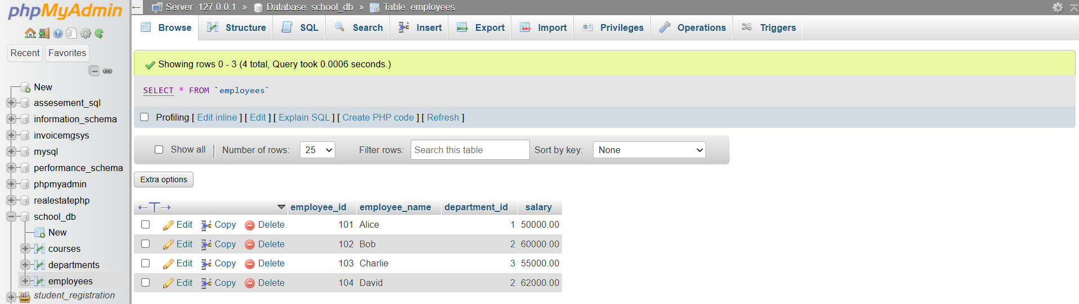

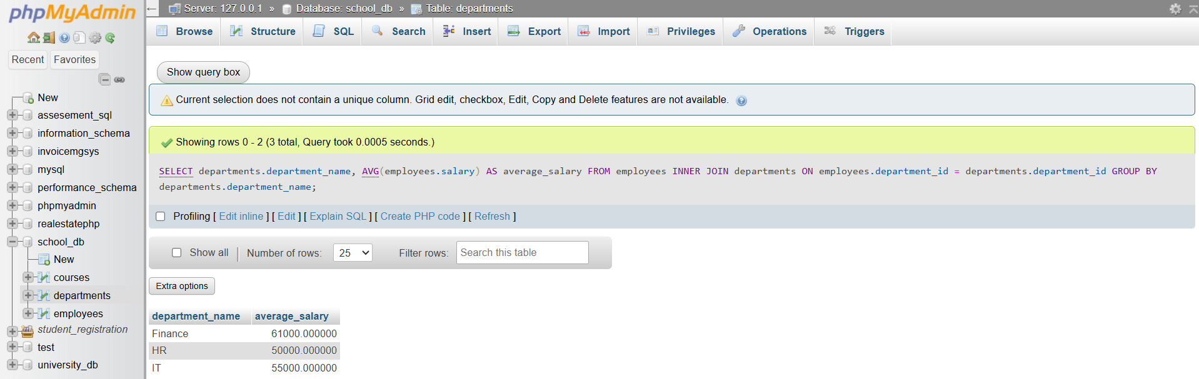

**SQL Stored Procedure**

**Lab 1: Write a stored procedure to retrieve all employees from the employees table based on department.**

**CODE:**

**CREATE PROCEDURE GetEmployeesByDepartment(IN dept_id INT)**

**BEGIN**

**SELECT employee_id, employee_name, salary**

**FROM employees**

**WHERE department_id = dept_id;**

**END $$**

**SCREENSHOT:**

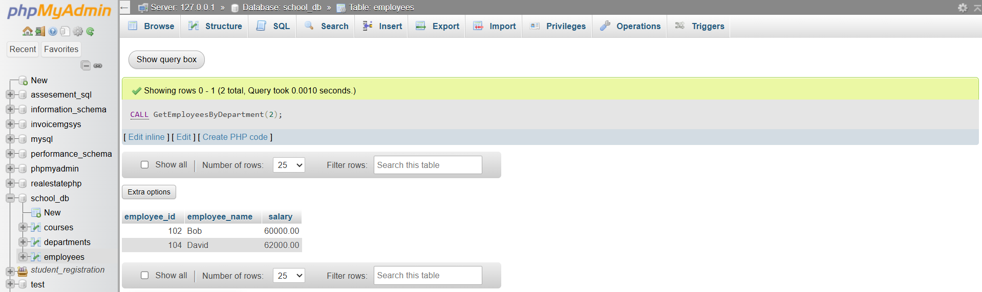

**Lab 2: Write a stored procedure that accepts course_id as input and returns the course details.**

**CODE:**

**CREATE PROCEDURE GetCourseDetails(IN c_id INT)**

**BEGIN**

**SELECT course_id, course_name, course_duration**

**FROM courses**

**WHERE course_id = c_id;**

**CALL GetCourseDetails(3);**

**SCREENSHOT:**

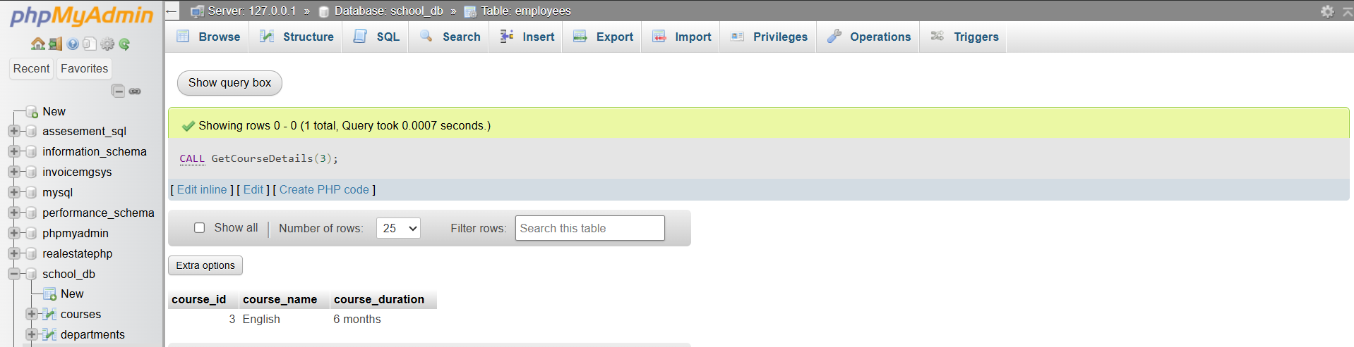

**SQL View**

**Lab 1: Create a view to show all employees along with their department names.**

**CODE:**

**CREATE VIEW EmployeeDepartmentView AS**

**SELECT e.employee_id, e.employee_name, d.department_name**

**FROM employees e**

**INNER JOIN departments d**

**ON e.department_id = d.department_id;**

**SCREENSHOT:**

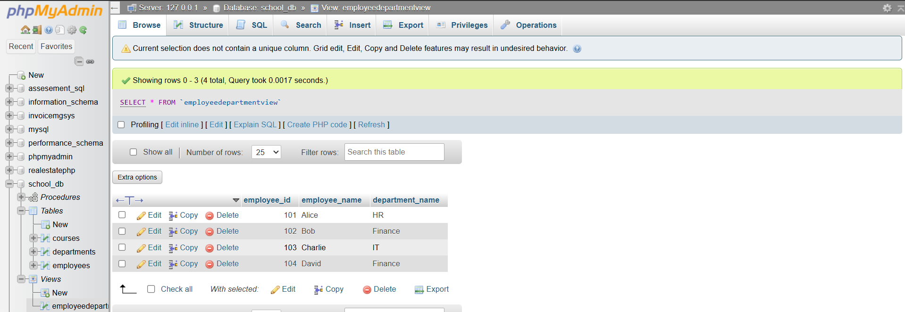

**Lab 2: Modify the view to exclude employees whose salaries are below $50,000.**

**CODE:**

**CREATE OR REPLACE VIEW EmployeeDepartmentView AS**

**SELECT e.employee_id, e.employee_name, e.salary, d.department_name**

**FROM employees e**

**INNER JOIN departments d**

**ON e.department_id = d.department_id**

**WHERE e.salary >= 50000;**

**SCREENSHOT:**

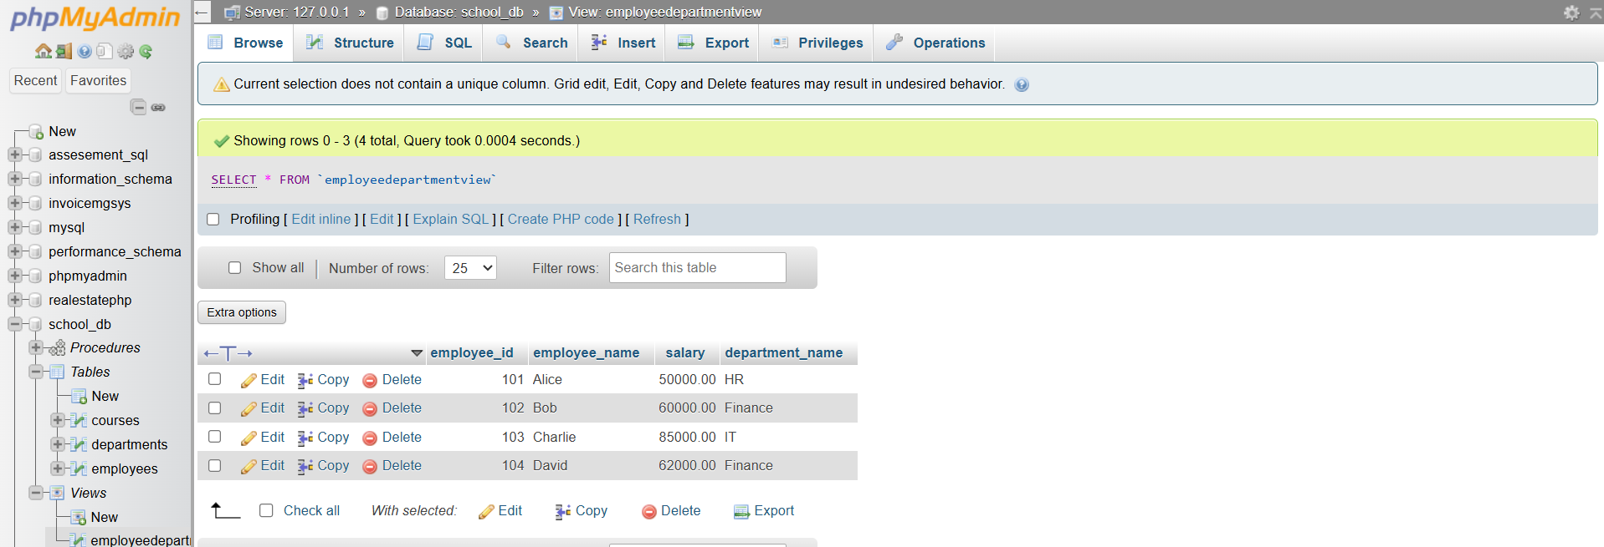

**SQL Triggers**

**Lab 1: Create a trigger to automatically log changes to the employees table when a new employee is added.**

**CODE:**

**CREATE TABLE employee_logs (**

**log_id INT AUTO_INCREMENT PRIMARY KEY,**

**employee_id INT,**

**action_type VARCHAR(50),**

**action_time TIMESTAMP DEFAULT CURRENT_TIMESTAMP**

**);**

**SCREENSHOT:**

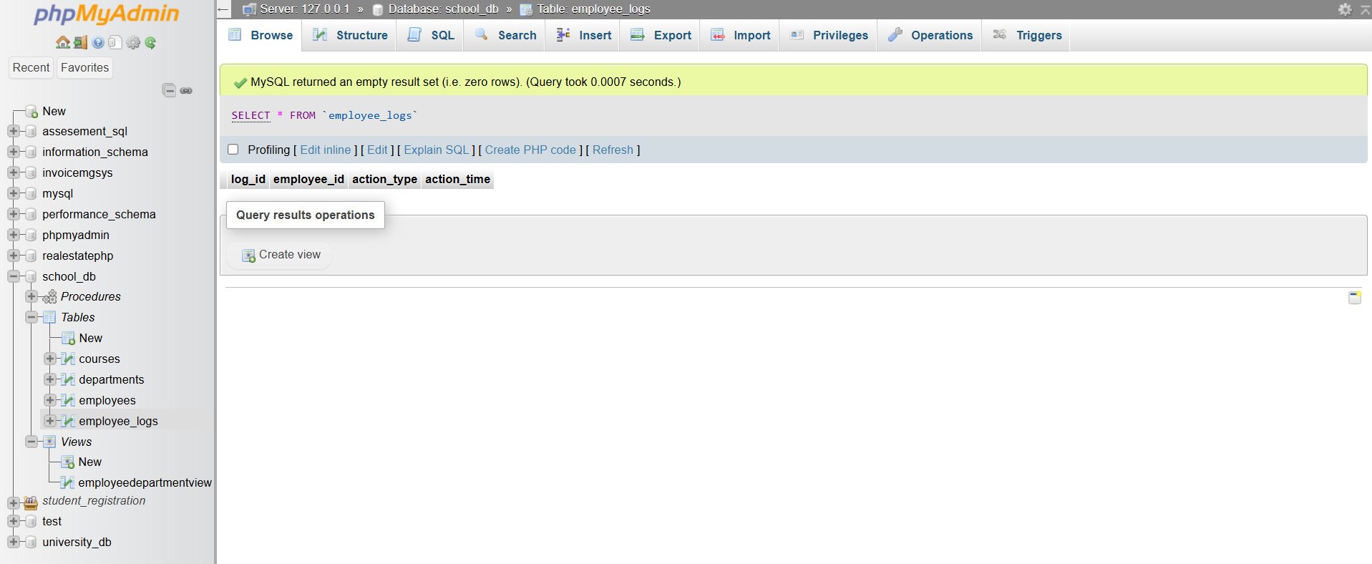

**Lab 2: Create a trigger to update the last_modified timestamp whenever an employee record is updated.**

**CODE:**

**CREATE TRIGGER update_employee_timestamp**

**BEFORE UPDATE ON employees**

**FOR EACH ROW**

**SET NEW.last_modified = CURRENT_TIMESTAMP;**

**SCREEENSHOT:**

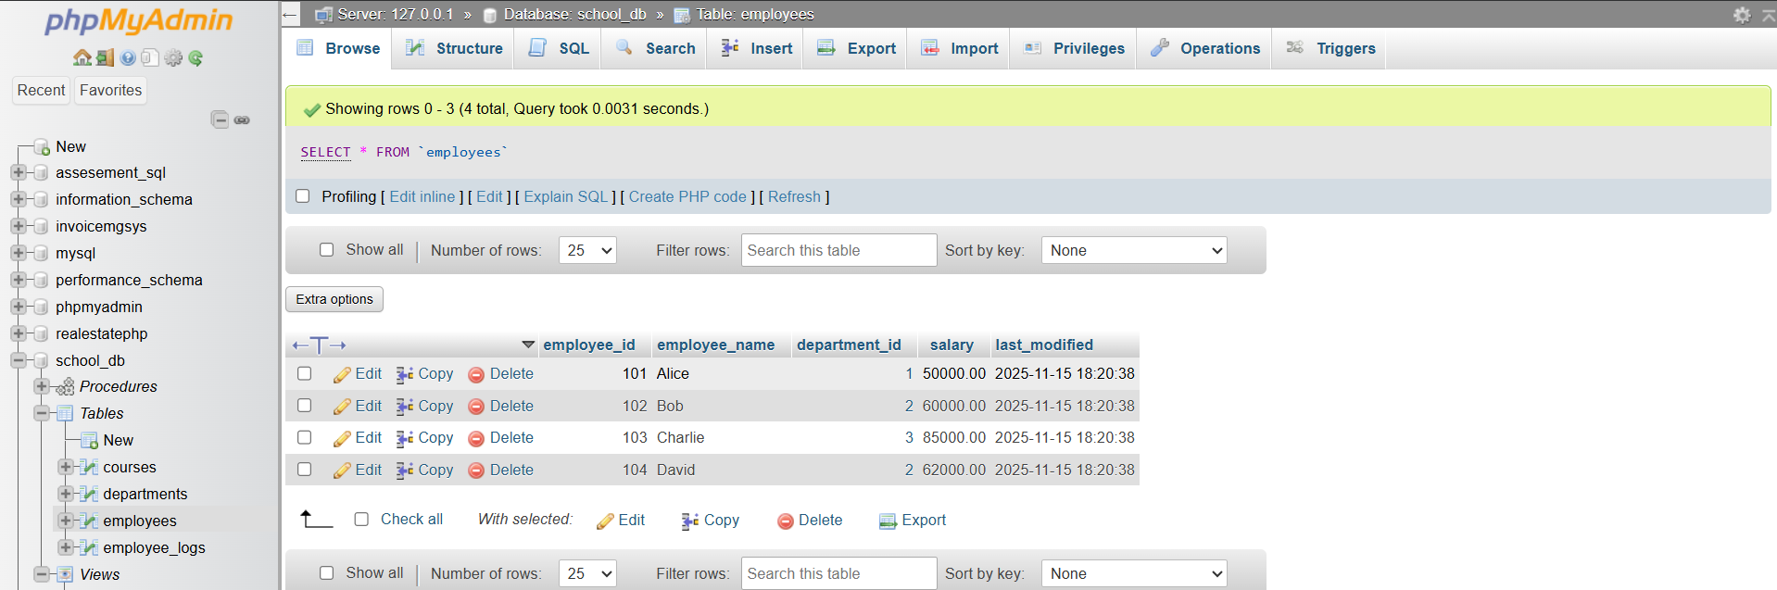

**Introduction to PL/SQL**

**Lab 1: Write a PL/SQL block to print the total number of employees from the employees table.**

**CODE:**

**SET @total := (SELECT COUNT(*) FROM employees);**

**SELECT CONCAT('Total Employees: ', @total) AS message;**

**SCREENSHOT:**

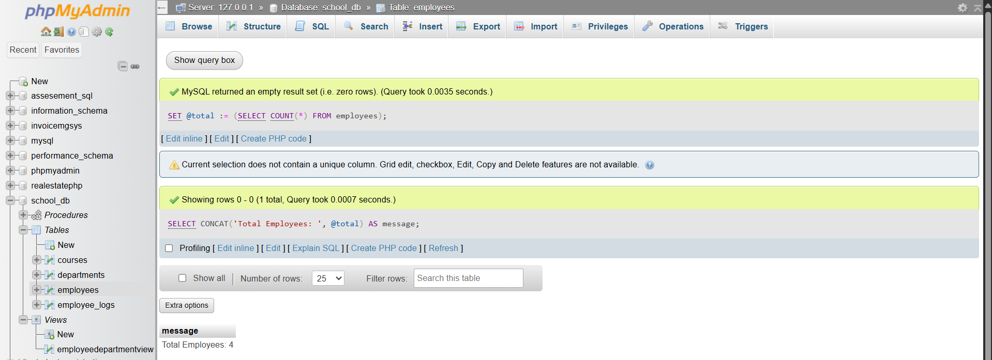

**Lab 2: Create a PL/SQL block that calculates the total sales from an orders table**.

**CODE:**

**SET @sales := (SELECT SUM(total_amount) FROM orders);**

**SELECT CONCAT('Total Sales: ', @sales) AS message;**

**SCREENSHOT:**



**PL/SQL Control Structures**

**Lab 1: Write a PL/SQL block using an IF-THEN condition to check the department of an employee.**

**CODE:**

**DELIMITER $$**

**CREATE PROCEDURE CheckEmployeeDept(IN emp_id INT)**

**BEGIN**

**DECLARE v_dept VARCHAR(100);**

**SELECT d.department_name INTO v_dept**

**FROM employees e**

**JOIN departments d ON e.department_id = d.department_id**

**WHERE e.employee_id = emp_id;**

**IF v_dept = 'HR' THEN**

**SELECT 'Employee works in Human Resources' AS message;**

**ELSE**

**SELECT 'Employee works in another department' AS message;**

**END IF;**

**END $$**

**DELIMITER ;**

**CALL CheckEmployeeDept(101);**

**SCREENSHOT:**

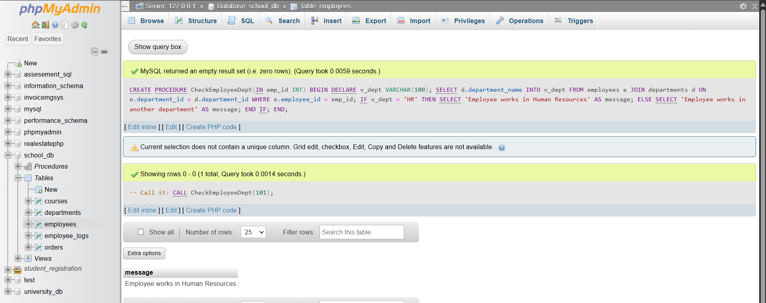

**Lab 4: Use a FOR LOOP in PL/SQL to display the details of all books one by one.**

**CODE:**

**CALL display_books();**

**SELECT * FROM book_output;**

**SCREENSHOT:**

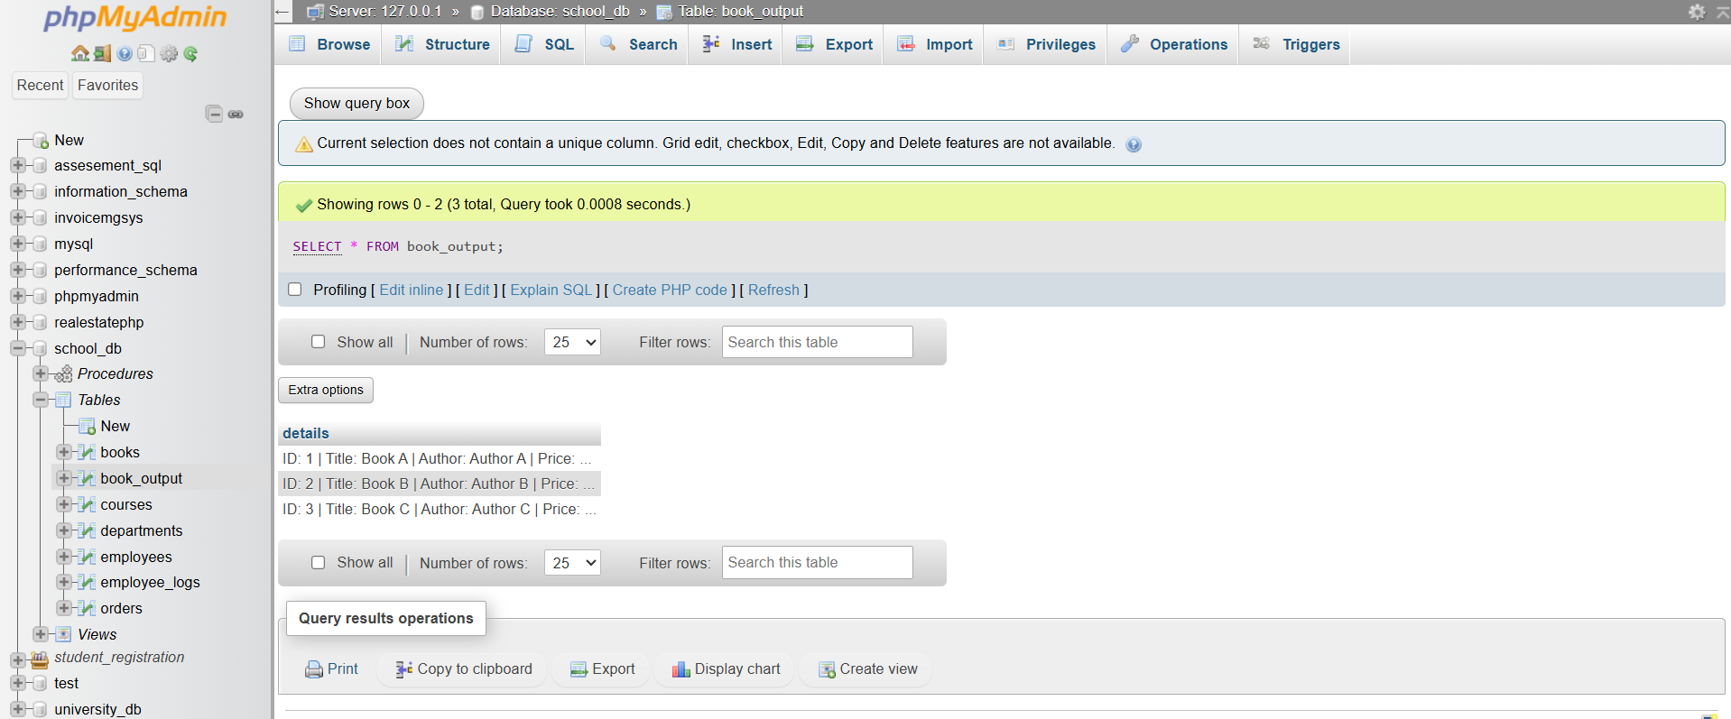

**SQL Cursors**

**Lab 3: Write a PL/SQL block using an explicit cursor to fetch and display all records from the members table.**

**CODE:**

**DROP TABLE IF EXISTS member_output;**

**CREATE TABLE member_output (**

**details VARCHAR(300)**

**);**

**DELIMITER $$**

**CREATE PROCEDURE display_members()**

**BEGIN**

**DECLARE done INT DEFAULT FALSE;**

**DECLARE m_id INT;**

**DECLARE m_name VARCHAR(100);**

**DECLARE m_email VARCHAR(100);**

**DECLARE member_cursor CURSOR FOR**

**SELECT member_id, member_name, email FROM members;**

**DECLARE CONTINUE HANDLER FOR NOT FOUND SET done = TRUE;**

**OPEN member_cursor;**

**read_loop: LOOP**

**FETCH member_cursor INTO m_id, m_name, m_email;**

**IF done THEN**

**LEAVE read_loop;**

**END IF;**

**INSERT INTO member_output VALUES (**

**CONCAT(**

**'ID: ', m_id,**

**' | Name: ', m_name,**

**' | Email: ', m_email**

**)**

**);**

**END LOOP;**

**CLOSE member_cursor;**

**END $$**

**DELIMITER ;**

**SCREENSHOT:**

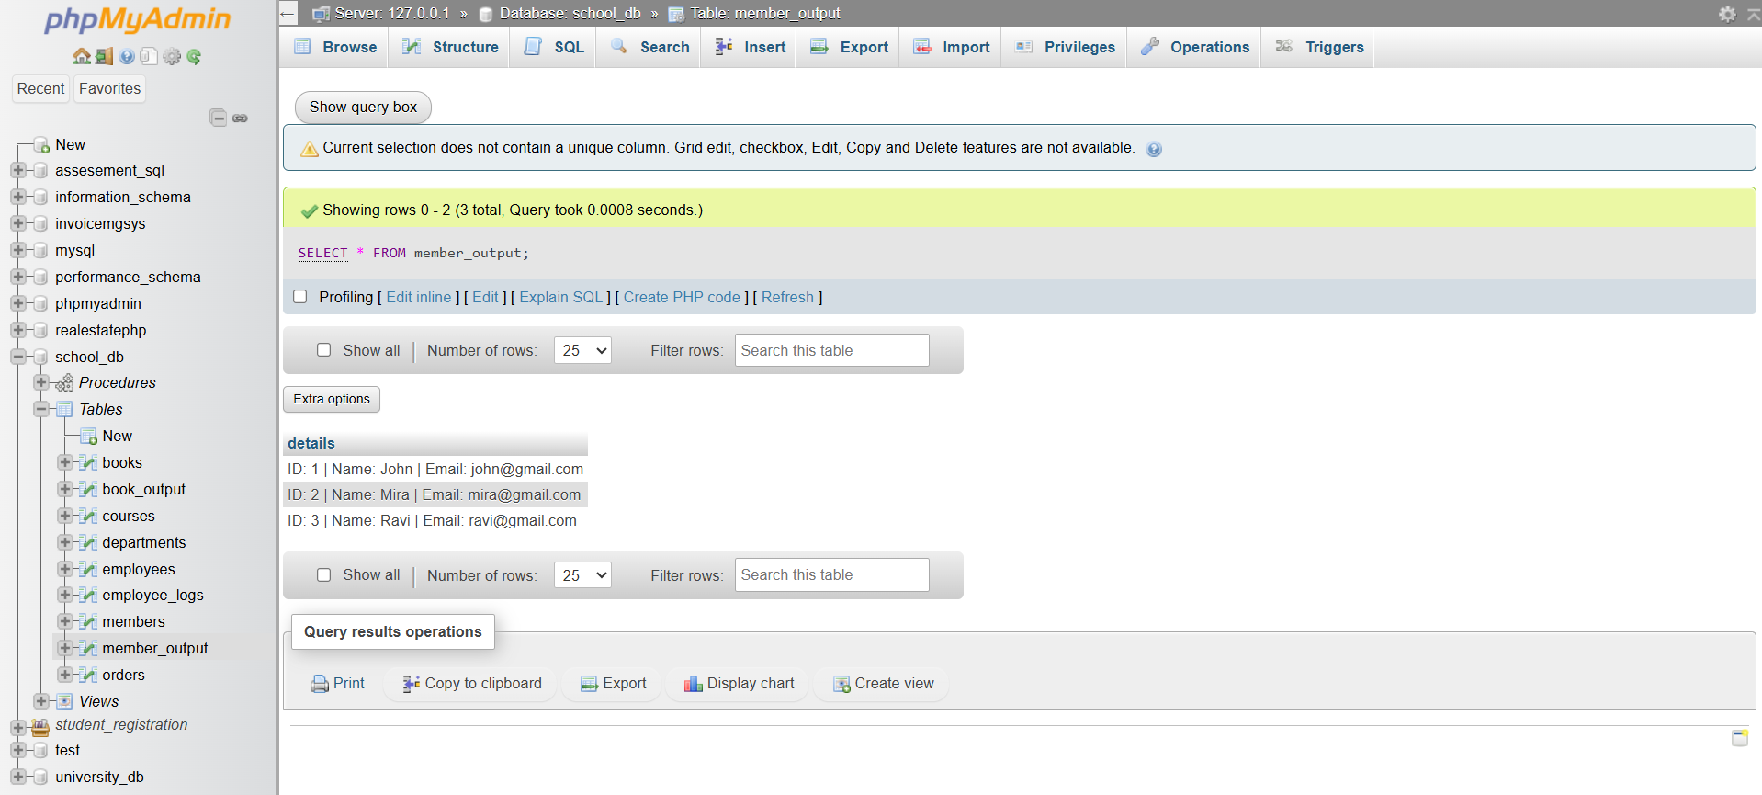

**Lab 4: Create a cursor to retrieve books by a particular author and display their titles.**

**CODE:**

**DELIMITER $$**

**CREATE PROCEDURE get_books_by_author(IN p_author VARCHAR(100))**

**BEGIN**

**DECLARE done INT DEFAULT FALSE;**

**DECLARE b_title VARCHAR(200);**

**DECLARE book_cursor CURSOR FOR**

**SELECT title FROM books WHERE author = p_author;**

**DECLARE CONTINUE HANDLER FOR NOT FOUND SET done = TRUE;**

**OPEN book_cursor;**

**read_loop: LOOP**

**FETCH book_cursor INTO b_title;**

**IF done THEN**

**LEAVE read_loop;**

**END IF;**

**INSERT INTO books_output VALUES (b_title);**

**END LOOP;**

**CLOSE book_cursor;**

**END $$**

**DELIMITER ;**

**SCREENSHOT:**

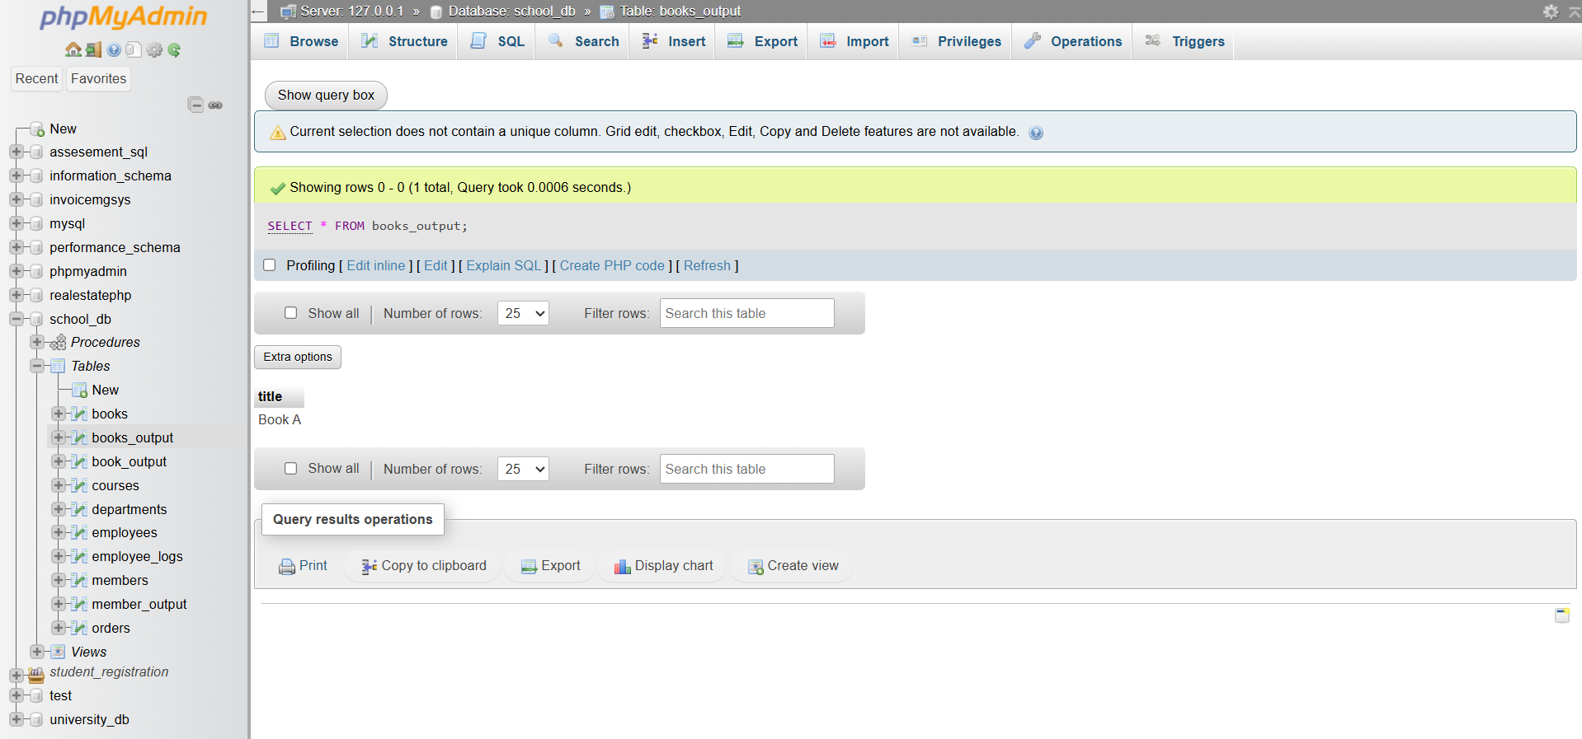

**Rollback and Commit Savepoint**

**Lab 3: Perform a transaction that includes inserting a new member, setting a SAVEPOINT, and rolling back to the savepoint after making updates.**

**CODE:**

**START TRANSACTION;**

**INSERT INTO members (member_id, member_name, email)**

**VALUES (10, 'Rahul', 'rahul@example.com');**

**SAVEPOINT sp1;**

**UPDATE members**

**SET member_name = 'Rahul Kumar'**

**WHERE member_id = 10;**

**UPDATE members**

**SET email = 'rahul.k@sample.com'**

**WHERE member_id = 10;**

**ROLLBACK TO sp1;**

**COMMIT;**

**SCREENSHOT:**

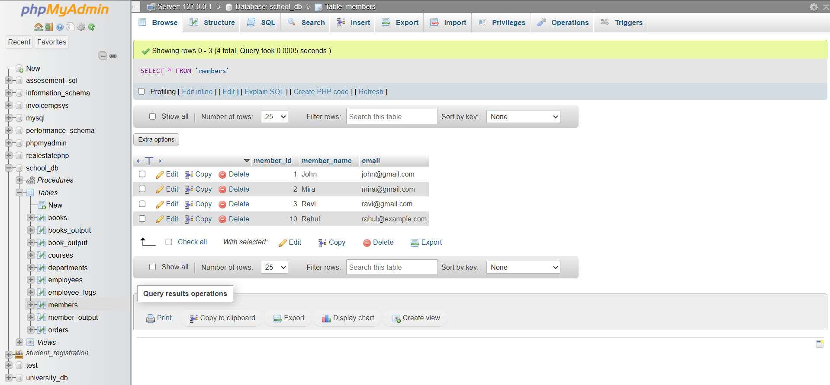

**Lab 4: Use COMMIT after successfully inserting multiple books into the books table, then use ROLLBACK to undo a set of changes made after a savepoint.**

**CODE:**

**START TRANSACTION;**

**INSERT INTO books (book_id, title, author, price)**

**VALUES**

**(101, 'Book One', 'Author A', 250),**

**(102, 'Book Two', 'Author B', 300),**

**(103, 'Book Three', 'Author A', 400);**

**COMMIT;**

**START TRANSACTION;**

**SAVEPOINT sp1;**

**UPDATE books SET price = 500 WHERE book_id = 101;**

**UPDATE books SET title = 'Updated Book' WHERE book_id = 102;**

**ROLLBACK TO sp1;**

**COMMIT;**

**SCREENSHOT:**

